Diem My



Diem My 9x is a Vietnamese actress and model. She was born in Ho Chi Minh City in Vietnam on January 27 1990. Her real name is Vũ Phạm Diễm My but she uses the artist name "Diem My 9x" with the 9x acting as a marker to distinguish her from another famous but older Vietnamese actress Diem My who was born in 1962. Diem My 9x is best known for her performance in [Lua Phat](https://www.imdb.com/title/tt2531258?ref_=nmbio_mbio) (2013), [Kung Fu Pho](https://www.imdb.com/title/tt5232488?ref_=nmbio_mbio) (2015) and [The Lady Assassin](https://www.imdb.com/title/tt3084836?ref_=nmbio_mbio) (2013).

She is a Buddhist, doesn’t smoke but drinks occasionally. She is single and yearns for a right person to enter into a romantic relationship with after breaking up with her boyfriend of 3 years. Her friends say she is constantly chatting about a possible new relationship with a man who is now a business man at a construction company in Australia.

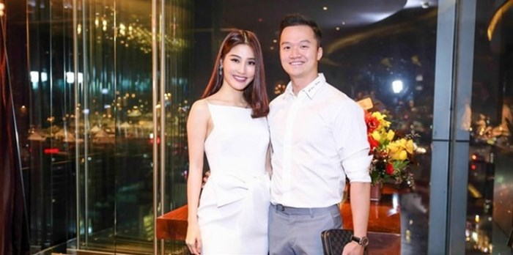**Diem My 9x with her New Boyfriend Working in Australia**

Diem My 9x is one of the most successful actresses in the whole of Asia and is revered for winning the “Woman in Film” award for her portrayal of Helen in the film “Co Ba Sai Gon” (The Tailor). She is 165 cm tall weighing in at 5okg. She has been described in several fashion magazines as a beautiful face of Vietnam.



Diem My 9x comes from a family with an enviable history in tailoring and a tailoring business that has spanned at least two generations. She was introduced at an early age to tailoring by her mother and grew up virtually in the family’s tailoring studio.

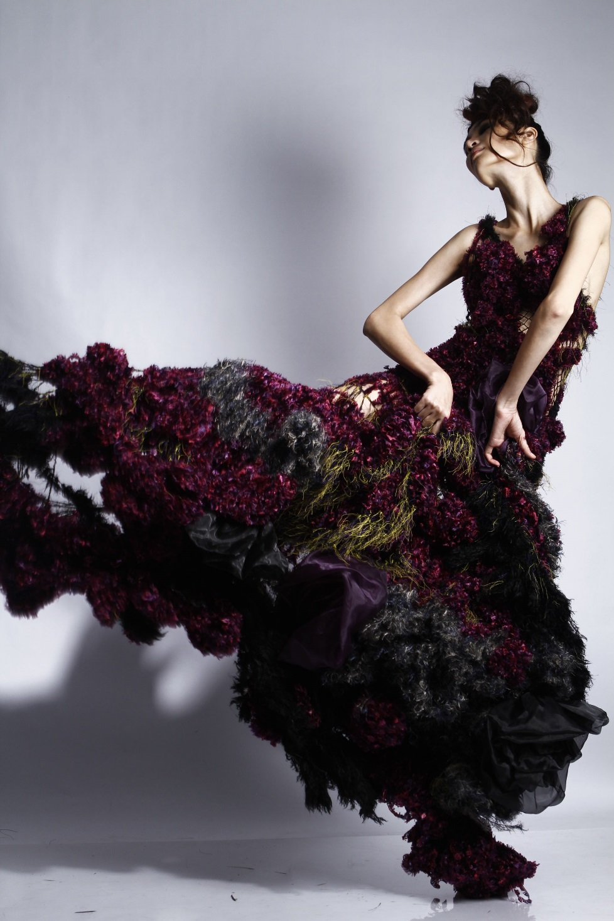

As a child, Diem My 9x was particularly intrigued by the beautiful collection of fabric that never ceased to pass through their studios and hand-crafting that was a specialty of Vietnamese tailors. Diem My was also a very intelligent child and by the age of 18 was fully prepared for higher education at Lotus University where she enrolled for the fashion design and modern art programme.

She graduated with a first class degree in December, 2010. While still at the University, she was a finalist at the 2009 Vietnam Collection Granprix. In her final year at the University she also contested and won the Idea prize in the Hutech Designer contest, and finished in first place at the Aquafina Pure Fashion.



Diem My 9x describes herself as a highly determined person who pays a lot of attention to details particularly in hand-crafting and textiles. For Diem My, failure is not an option. She has a strong belief people can achieve anything provided they work hard and put in their best.



. Diem My 9x is very bold. She is not your everyday Vietnamese Bhuddist. She is prepared to explore new avenues and has modelled in hot photos

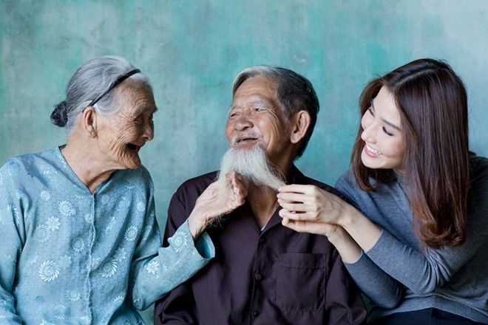Diem My 9x appears in the latest photo collection ‘Ageless Beauty’ of French photographer Rehahn Croquevielle

Apart from being a popular Vietnamese actress and model Diem My 9x, is a passionate supporter of the Vietnamese soccer team. She has been known to do several nutty things to motivate the national soccer players. She astounded every one last week when she declared that she would reward each of the national soccer players with a kiss if they won a gold medal at the forthcoming Southeast Asian Games tournament.



.

Diem My 9x adds a compassionate side to her personality. Despite having one of the busiest schedules in show business, the actress and model pays regular visits to a number of provinces across the country to bring gifts to people in need. She is also involved in the organisation of several charitable events.

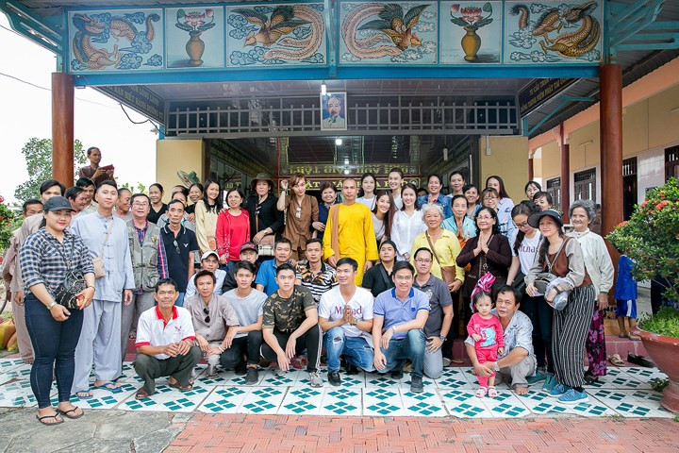

**Diem My 9x takes a photo with members of the charity group**